**Loading files from local to s3 using SFTP server**

Steps followed:

1. Create s3 bucket.
2. Create Iam policy and Iam role.
3. Create SFTP server.
4. Generate SSH key
5. Connect SFTP with WinSCP.
6. Transfer files from WinSCP.
7. Created s3 bucket with name “sherpoint-data”

a)Login to aws account

b)Click on buckets

c)Click on create bucket

d)Give the bucket name and create bucket.

1. Creation of Iam Policy

a)Click on I am

b)Go to Policies

c)Click on create policy

d)Give the permissions for the policy by clicking on Json.

e)Below is the permission file for Iam Policy.

1. Creation of SFTP server.
2. Transfer Family 🡪Servers🡪Create Server
3. Choose Identity provider as Service Managed.
4. Choose endpoint as publicly Accessible.
5. Choose domain as s3
6. In additional configuration Create new log group.
7. Click on review and create.

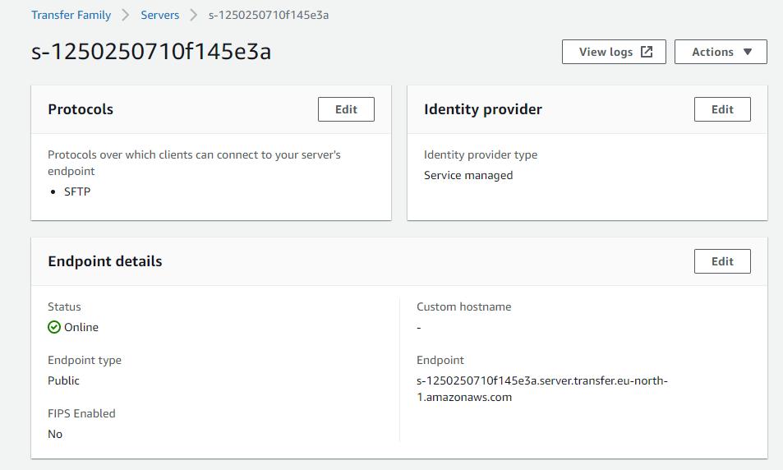



1. After creating the SFTP server, we need to add user to the server. Before that we need to generate an SSH key which is added to the user.  
   For generating the SSH key we have used puTTygen.

After generating the SSH key copy the key and save it as private key for further usage.

1. Now in the SFTP server click on add user and add the user, paste the generated SSH key in that user.
2. We have added the user with the name “sftp-user”.

1. Connect SFTP with WinSCP
2. Download and install WinSCP.
3. While connecting WinSCP to s3, we should provide SFTP server endpoint as Host name and SFTP username as username.

1. In the advanced settings in SSH authentication browse the SSH private key saved earlier. Click on ok and login.

To avoid future timestamp errors uncheck the preserved timestamp (preferences🡪Transfer🡪Default).

1. Now WinSCP interface is ready for usage.

Left side is local environment and right side is the s3 environment we have given. We just need to drag and drop the files, so that files will reflect in aws s3.